**Experiment 11**

**Name: Aayush Kumar**

**R171218002**

**Aim:** Installation and execution of vagrant

**Procedure:**

**Step 1:** Download vagrant from the official website of HashiCorp.

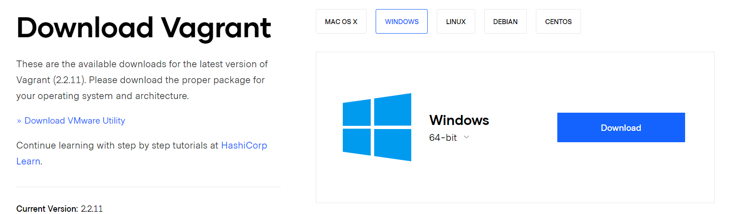

**Step 2:** Run the exe file to install vagrant.

**Step 3:** Create a directory and initialise it using the ‘vagrant init’ command.

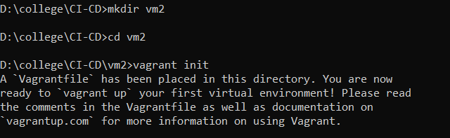

**Step 4:** After the end of step 3 a vagrant file is created and by editing this file we will decide the configuration of the vms that will be created by vagrant. Here we have made the following changes:

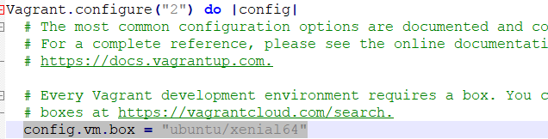

**Step 5:** Run the ‘vagrant up’ command to create the vm. Here first the Ubuntu is downloaded and then the vm is created. At the end of this step a vm has been created.

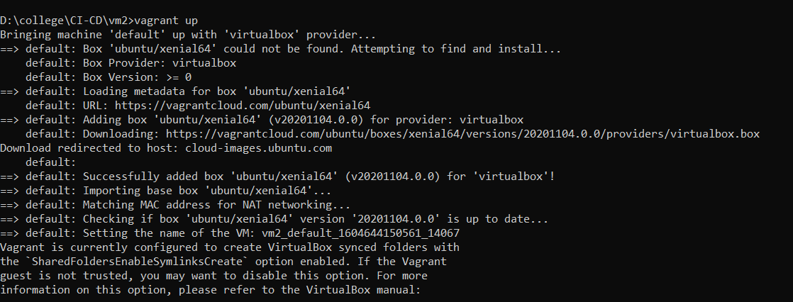

**Step 6:** Run the ‘vagrant ssh’ command to a attach the vm created to the windows command line. Now a command line of Ubuntu has opened.

